

**II Semester 2024-2025**

**PROJ 3001 Special Project I**

**PROJ 3002 Special Project II**



**“Lotus Shrine”**

# **Acknowledgement**

We would like to express our sincere gratitude to the Myanmar Institute of Information Technology (MIIT) for their support in enabling the completion of the “Lotus Shrine” project. We extend our deepest appreciation to Dr. Win Aye (Rector), Dr. Myat Thuzar Tun (Pro-Rector and our Instructor in Charge), and Dr. Khaing Nyunt Myaing (Pro-Rector) for providing us with this valuable opportunity.

We are especially grateful to our supervisor, **Dr. Phyu Myo Thwe**, for her expert guidance, constructive feedback, and encouragement throughout the development of this project. Her knowledge and advice have been indispensable in ensuring the success and quality of our work.

Finally, we wish to acknowledge the commitment and collaboration of all Lotus Shrine project members. Their dedication, teamwork, and hard work have been essential in bringing this project to fruition.

**Certificate**

This is to certify that the project report titled **"Lotus Shrine"** was undertaken by **Mg Pai Min Thway (2022-MIIT-CSE-002) and Mg Khant Nyar Thwin (2022-MIIT-CSE-018) , Ma Myat Mon Mon Zaw (2022-MIIT-CSE-027)** , students of the **Computer Science and Engineering Major** at the **Myanmar Institute of Information Technology (MIIT), Mandalay**.

The project was successfully completed under the guidance of **Project Supervisor Dr. Phyu Myo Thwe** at the same institution. This report is an original work and has not been submitted to any other organization for any purpose.

**Project Supervisor**

Dr. Phyu Myo Thwe

# **Abstract**

The Lotus Shrine project is an innovative web-based application designed to provide a virtual platform for Buddhist meditation and prayer, catering to users who may not be able to physically travel to pagodas or monasteries. It seamlessly blends ancient Buddhist practices with modern web development and AI integration to foster mindfulness, peace, and cultural connection.

This final report confirms the successful completion of the project. All core features have been fully implemented and integrated, including immersive pagoda viewing, guided meditation sessions with AI-based posture detection, and the personalized 'Koe Na Win Dashboard' for managing spiritual vows. The application is now a fully functional and polished platform. Following the upcoming final seminar, the project will be ready for deployment, providing a meaningful spiritual tool for users worldwide.

## **Table of Contents**

|  |  |  |
| --- | --- | --- |
| **No.** | **Title** | **Page** |
| 1 | Introduction | 1 |
|  | 1.1 Introduction to the Project | 1 |
|  | 1.2 Project Overview and Scope | 1 |
|  |  |  |
| 2 | Project Objectives | 2 |
|  |  |  |
| 3 | Background and Core Technologies | 4 |
|  | 3.1 Frontend Development | 4 |
|  | 3.2 Backend Development | 5 |
|  | 3.3 Database Management | 5 |
|  |  |  |
| 4 | Project Overview and Implementation | 7 |
|  | 4.1 Overall Project Structure and Flow | 7 |
|  | 4.2 Use Case Diagram | 8 |
|  | 4.3 Application Flowchart | 9 |
|  | 4.3.1 Main Application Flowchart | 9 |
|  | 4.3.2 Services Flowchart | 10 |
|  | 4.3.3 Koe Na Win Flowchart | 11 |
|  | 4.3.4 About Us Flowchart | 12 |
|  | 4.3.5 Account Management Flowchart | 13 |
|  | 4.4 Entity-Relationship (ER) Diagram | 14 |
|  |  |  |
| 5 | Implementation and Features | 15 |
|  | 5.1 Key Feature Implementation | 15 |
|  | 5.2 Component Communication and State Management | 17 |
|  | 5.3 Build and Deployment Considerations | 17 |
|  |  |  |
| 6 | User Interface and Experience | 18 |
|  | 6.1. Overview | 18 |
|  | 6.2. Design Principles | 18 |
|  | 6.3 User Interface Design | 19 |
|  | 6.3.1 Home Page | 19 |
|  | 6.3.2. Login Page | 19 |
|  | 6.3.3 Sign in Page | 20 |
|  | 6.3.4 Pagoda Page | 20 |
|  | 6.3.5 Pagoda Page (Pagoda History Function) | 21 |
|  | 6.3.6 Pagoda Page (Pagoda Pray Function) | 21 |
|  | 6.3.7 Pagoda Page (Pagoda Pray Function (Cont.)) | 22 |
|  | 6.3.8 Mantras Page | 22 |
|  | 6.3.9 Mantras Page (Cont.) | 23 |
|  | 6.3.10 Sermon Page | 23 |
|  | 6.3.11 Dhamma Books Page | 24 |
|  | 6.3.12 Meditation Page | 24 |
|  | 6.3.13 Meditation Page (Cont.) | 25 |
|  | 6.3.14 Meditation Page (Cont.) | 25 |
|  | 6.3.15 Koe Na Win Page | 26 |
|  | 6.3.16 Koe Na Win Grades Page | 26 |
|  | 6.3.17 Project Objectives Page | 27 |
|  | 6.3.18 About Developers Page | 27 |
|  | 6.3.19 My Account Page | 28 |
|  | 6.3.20 Edit Account Page | 28 |
|  | 6.3.21 Koe Na Win Dashboard Main Page | 29 |
|  | 6.3.22 Koe Na Win Dashboard Information Page | 29 |
|  | 6.3.23 Koe Na Win Dashboard Certificate Page | 30 |
|  |  |  |
| 7 | Future Enhancement and Considerations | 29 |
|  |  |  |
| 8 | Conclusion | 30 |

**List of Figures**

|  |  |  |
| --- | --- | --- |
| **No.** | **Figure Title** | **Page** |
| **4.2** | Use Case Diagram | 8 |
| **4.3.1** | Main Application Flowchart | 9 |
| **4.3.2** | Services Section Flowchart | 10 |
| **4.3.3** | Koe Na Win Dashboard Flowchart | 11 |
| **4.3.4** | About Us Section Flowchart | 12 |
| **4.3.5** | Account Management Flowchart | 13 |
| **4.4** | Entity-Relationship (ER) Diagram | 14 |
| **6.1** | Color Palette of Lotus Shrine | 18 |
| **6.2** | Home Landing Page | 19 |
| **6.3** | Home Landing Page | 19 |
| **6.4** | Sign In Page | 20 |
| **6.5** | Pagoda Page | 20 |
| **6.6** | Pagoda Page (Pagoda History Function) | 21 |
| **6.7** | Pagoda Page (Pagoda Pray Function) | 21 |
| **6.8** | Pagoda Page (Pagoda Pray Function (Cont.)) | 22 |
| **6.9** | Mantras Page | 22 |
| **6.10** | Mantras Page (Cont.) | 23 |
| **6.11** | Sermon Page | 23 |
| **6.12** | Dhamma Books Page | 24 |
| **6.13** | Meditation Page | 24 |
| **6.14** | Meditation Page (Cont.) | 25 |
| **6.15** | Meditation Page (Cont.) | 25 |
| **6.16** | Koe Na Win Page | 26 |
| **6.17** | Koe Na Win Grades Page | 26 |
| **6.18** | Project Objectives Page | 27 |
| **6.19** | About Developers Page | 27 |
| **6.20** | My Account Page | 28 |
| **6.21** | Edit Account Page | 28 |
| **6.22** | Koe Na Win Dashboard Main Page | 29 |
| **6.23** | Koe Na Win Dashboard Information Page | 29 |
| **6.24** | Koe Na Win Dashboard Certificate Page | 30 |

# **Chapter – 1**

# **Introduction**

## **1.1 Introduction to Lotus Shrine**

The Lotus Shrine project is a web application designed to offer a virtual Buddha Pay Homage room, providing comprehensive virtual Buddhist meditation and prayer experiences. This initiative aims to bridge the gap for individuals who may be unable to physically travel to pagodas or monasteries. In an increasingly digital world, the demand for accessible spiritual practices has grown, and this project seeks to meet that need by thoughtfully combining ancient Buddhist traditions with modern web development and artificial intelligence. Our overarching goal is to create a peaceful, user-friendly, and technologically advanced digital space that supports and deepens individual spiritual journeys, promoting mindfulness and devotion irrespective of geographical limitations.

## **1.2 Project Overview and Scope**

The Lotus Shrine app creates a virtual Buddha Pay Homage room. Here, users can access Buddha Teachings through audio and video. They can also meditate using a timer, with the option to play offering audio continuously during meditation or as background sound on the website. The app offers virtual pagoda visits. A special feature lets users see the pagoda from a specific "corner" (like the Monday corner) based on their birthday. Meditation sessions get better with AI-powered posture feedback in real-time. Users can also find traditional chants and daily Dhamma quotes.

A key part of the app is the "Koe Na Win Dashboard." This feature helps users in Myanmar with their traditional Buddhist bead-counting practice. It sends timely alarms and notifications (by message or email) and shows what tasks or prayers need to be done each day. This report shows our progress and what still needs to be done to finish the Lotus Shrine. Chapter 2 explains the project objectives in more detail, and Chapter 4 will cover implementation specifics.

## **Chapter – 2**

## **Project Objectives and Our schedules**

## **2.1 Project Objectives**

The core objectives guiding the development of the Lotus Shrine web application are to:

* ***Promote mindfulness and spiritual connection***: To leverage accessible digital technology to foster mindfulness, devotion, and a deeper connection to Buddhist practices in the modern age, ultimately aiming for inner peace for all users.
* ***Provide a comprehensive virtual platform:*** To offer an accessible and inclusive digital space for Buddhist meditation and prayer experiences for users worldwide, regardless of their physical location.
* ***Develop the Koe Na Win Dashboard:*** To build and integrate the personalized "Koe Na Win Dashboard" for logged-in users, enabling them to start new or resume existing 81-day vows, track daily progress with visual indicators, manage meat-free day reminders, log daily completions, view stage-specific mantras, and maintain a historical record of their spiritual practice.
* ***Create immersive virtual environments:*** To develop an immersive pagoda viewing experience that realistically simulates a physical visit, including the ability to view the pagoda from specific traditional "corners" (e.g., Monday corner) corresponding to a user's birthday, thereby enhancing the spiritual connection.
* ***Integrate intelligent posture detection:*** To implement guided meditation sessions with AI-powered posture detection using Google Teachable Machine, providing real-time feedback to users for improved alignment and practice.
* ***Ensure privacy and security:*** To prioritize user privacy and data security by requesting clear permissions for webcam access, ensuring no video data is stored or transmitted, providing options to turn posture detection on/off, and securely storing all logged-in user data accessible only to them.

## **2.2 Project Schedule**

|  |  |
| --- | --- |
| **Weeks** | **Description** |
| **Weeks 1-2** | Initiate the project by organizing the team and collecting detailed requirements. Define and finalize the project goals, deliverables, and overall system specifications. |
| **Weeks 3-4** | Create the system's architecture and design the database structure. Begin UI/UX design using Figma by developing wireframes and interactive prototypes. Start front-end development using React.js along with HTML, CSS, and JavaScript. |
| **Weeks 5-6** | Enhance the UI/UX designs and commence back-end development with PHP. Establish the MySQL database and implement connections between front-end and back-end components. |
| **Week 7** | Integrate AI-driven posture detection using Google Teachable Machine and test its functionality within the meditation feature. |
| **Week 8** | Prepare and deliver the Mid-Semester Seminar and report. Showcase the project progress, including UI/UX prototypes and AI integration demos. |
| **Weeks 9-11** | Finalized the development and integration of the Koe Na Win Dashboard, implementing vow management, progress tracking, and mantra systems. |
| **Weeks 12-14** | Conducted comprehensive system integration testing, user acceptance testing (UAT), and refined the UI/UX based on feedback. |
| **Weeks 15-16** | Performed final debugging, optimization, and completed all documentation. |
| **Week 17** | Submit the final report and conduct the final seminar presentation, demonstrating the fully functional Lotus Shrine web application. |

# **Chapter - 3**

# **Background and Core Technologies**

The development of the **Lotus Shrine** web application is built upon a robust and modern technical stack, carefully selected to ensure a responsive, interactive, and secure user experience. This section outlines the core technologies utilized across the frontend, backend, and database components of the project.

## **3.1. Frontend Development**

The client-side of the application is primarily developed using **React.js**, leveraging its component-based architecture for building a dynamic and user-friendly interface. Components are organized to handle specific features and views, allowing for modular development and maintainability.

* **HTML:** Provides the fundamental page structure for all web interfaces.
* **CSS (with Tailwind CSS):** Manages the styling and layout, ensuring a modern and responsive design across various devices. **Components from ShadCN/UI are integrated to provide consistent, accessible, and aesthetically pleasing UI elements, leveraging Tailwind CSS for utility-first styling.**
* **JavaScript / TypeScript:** Serves as the core logic and interactivity layer. TypeScript is used throughout the project for enhanced code quality and type safety, facilitating robust development of features.
* **Vite:** This build tool is employed to provide a fast development environment and efficient bundling of frontend assets.
* **Asset Management:** Various assets, including images for features (e.g., virtual pagoda, meditation), custom fonts, and background audio for immersive experiences, are systematically managed and integrated into the frontend.
* **Animation Libraries:** **"Framer Motion is used for smooth page transitions and component animations, such as those in the Koe Na Win dashboard progress indicators"**, while **GSAP (GreenSock Animation Platform) is utilized for more complex, high-performance animations, adding rich visual effects and enhancing user engagement.**
* **State & Notifications**: Sonner is used for toast notifications to provide user feedback for actions like vow creation or daily completion.

## **3.2. Backend Development**

The server-side logic and API management for Lotus Shrine are handled by **PHP**. The backend is structured to support user interactions and data retrieval for the frontend.

* **User Management:** Functions are implemented to handle user registration, email verification, login authentication, password updates, and account recovery. These functions connect securely with the database to manage user credentials.
* **Content Fetching:** APIs are in place to dynamically retrieve content, such as daily Dhamma quotes, which are then delivered to the frontend for display and to handle all CRUD operations for the Koe Na Win vow management system, including creating vows, updating daily progress, and fetching user history.
* **Communication:** Backend scripts manage contact form submissions, allowing users to send inquiries or feedback.
* **API Development:** PHP forms the backbone for building various API endpoints that facilitate seamless communication and data exchange between the React.js frontend and the MySQL database.

## **3.3. Database Management**

**MySQL** serves as the relational database for the application, responsible for securely storing and managing all project data.

* **Schema:** The database schema is defined using SQL, outlining the structure for storing different types of data, including user information, prayer logs, meditation records, and Dhamma quotes.
* **Data Operations:** Custom PHP classes are developed to interact with the MySQL database, enabling efficient CRUD (Create, Read, Update, Delete) operations. This allows the application to save user-specific data (like prayer history and reminders), manage user accounts, and retrieve content as needed.
* **Security Measures:** Mechanisms are in place within the database interaction layer to handle user data securely, including aspects like rate limiting for certain operations and protecting sensitive user information.

By combining these technologies, the Lotus Shrine project aims to deliver a seamless, feature-rich, and spiritually enriching experience.

## **Chapter - 4**

## **Project Overview and Implementation**

The Lotus Shrine web application is structured to deliver a rich, interactive, and spiritually enriching experience through a well-defined architecture and systematic implementation. This section details the overall project structure, key features, and how various components integrate to achieve the stated objectives.

## **4.1. Overall Project Structure and Flow**

The project follows a standard modern web application structure, separating frontend and backend concerns for efficient development and scalability.

* **Frontend (User Interface):** Built with React.js and TypeScript, the frontend handles all user interactions, visual presentation, and client-side logic. The application's entry point renders the main application component, which manages global providers (like the music player context) and client-side routing. Users navigate through various pages such as the home screen, meditation sessions, Dhamma teachings, traditional chant sections, the Koe Na Win dashboard, and authentication flows (login and sign-in).
* **Backend (Server-side Logic):** Developed in PHP, the backend is responsible for managing server-side operations, handling API requests from the frontend, and interacting with the database. It provides functionalities for user authentication, data retrieval (e.g., Dhamma quotes), and communication (e.g., contact forms).
* **Database (Data Storage):** MySQL serves as the data repository, storing all persistent information, including user details, prayer logs, meditation records, and content like Dhamma quotes and mantra data.

The communication flow is primarily **Frontend (React) ←→ Backend (PHP) ←→ Database (MySQL)**, with data exchanged via a RESTful API using JSON.

## **4.2. Use Case Diagram**

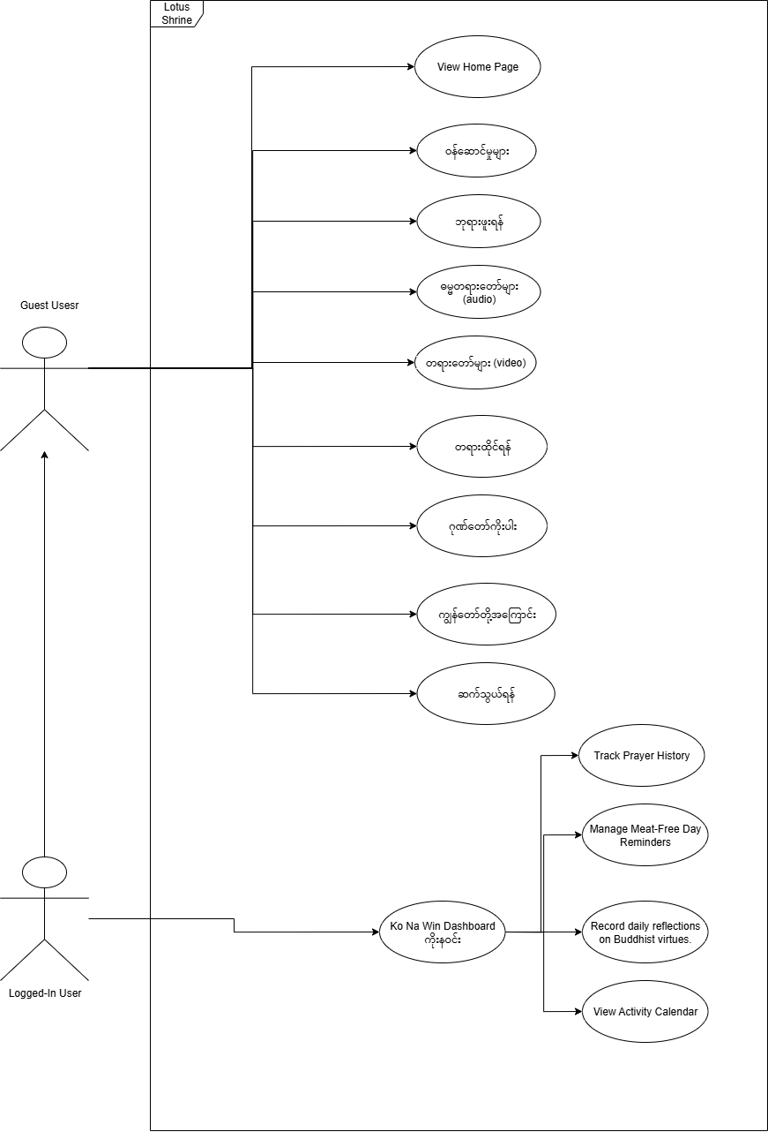Figure 4.2: Use Case Diagram – Lotus Shrine Web Application

## **4.3. Application Flowcharts**

## 4.3.1 Main Application Flowchart

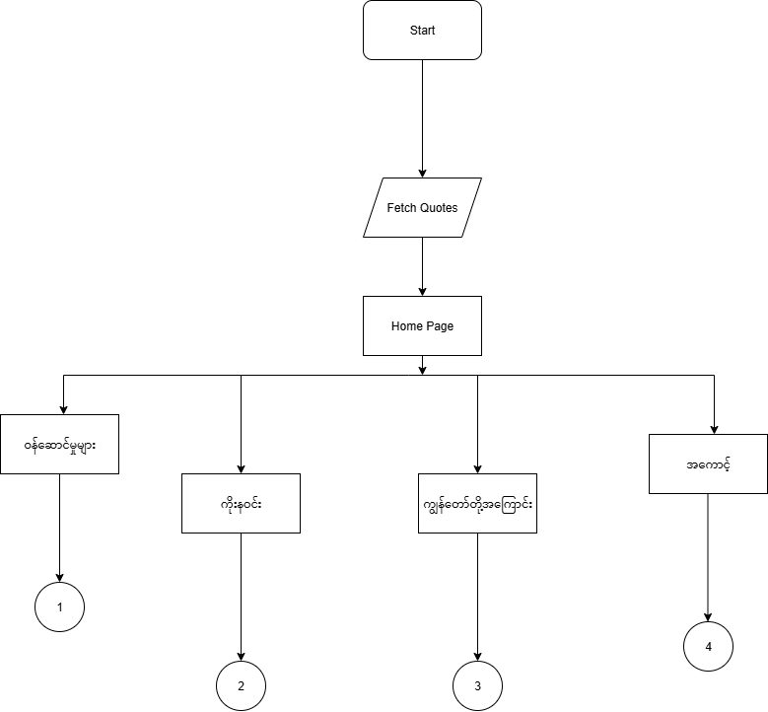This flowchart outlines the primary navigation paths starting from the application's entry point, showing how users move from the home page to the main feature sections.

Figure 4.3.1: Main Application Flowchart

**Description:** This diagram illustrates the initial user journey from the application's start, through fetching daily quotes and landing on the home page. It then branches out to the main sections of the application: Services, Koe Na Win, About Us, and Account Management, each leading to their respective detailed sub-flows.

## 4.3.2 Services Flowchart

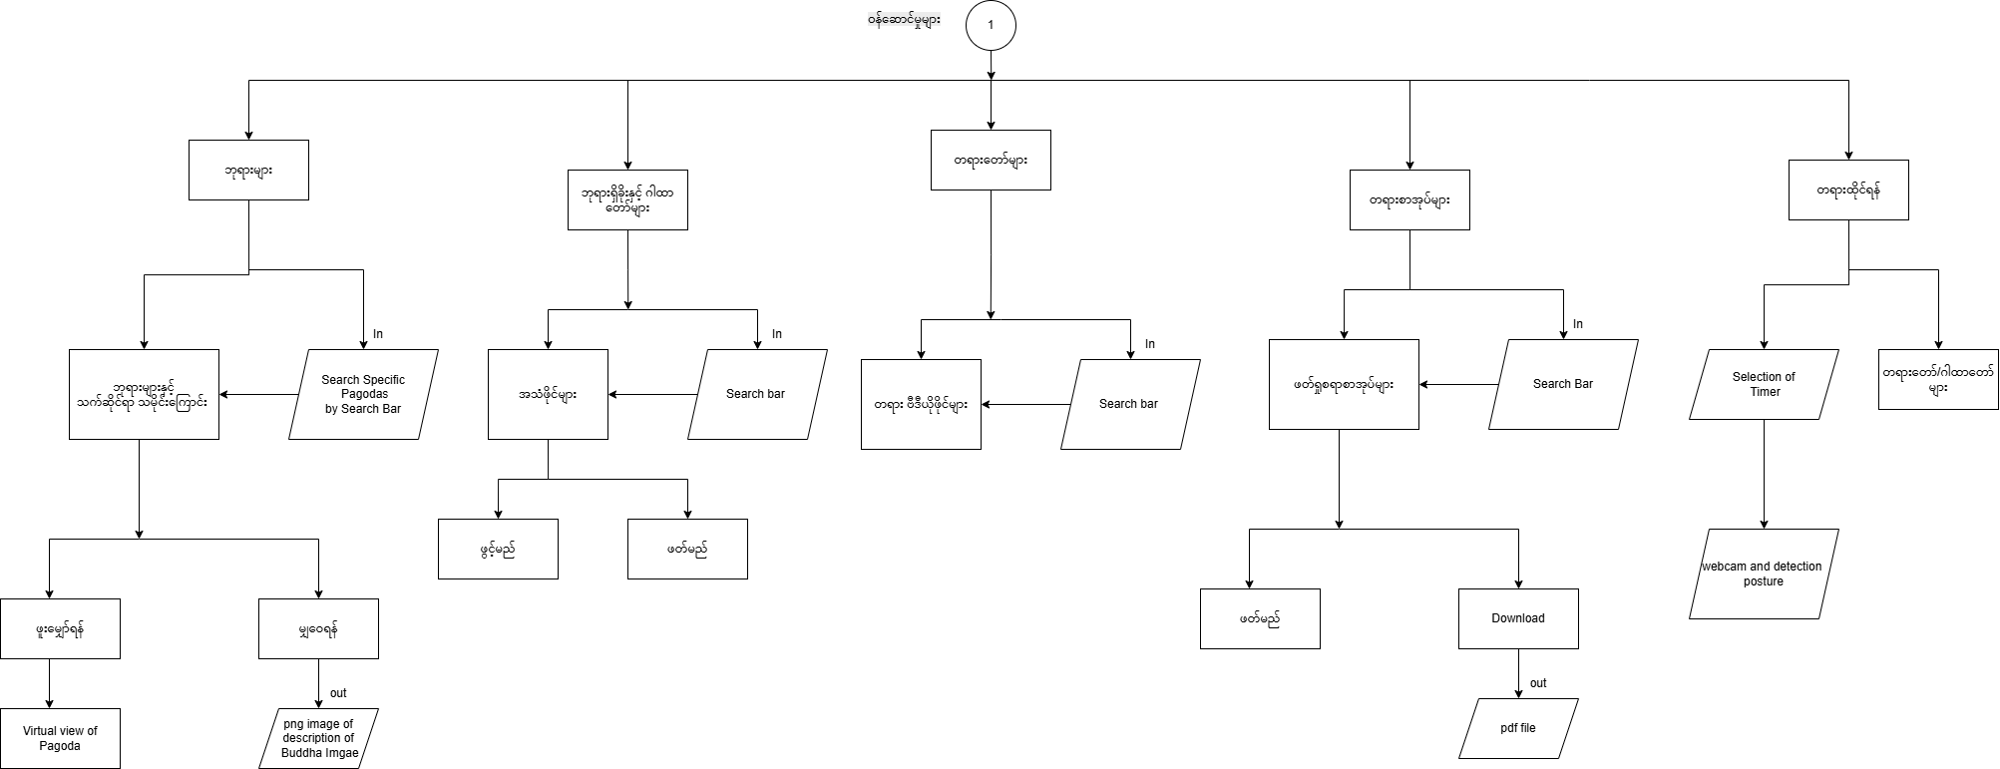This flowchart details the functionalities available within the "ဝန်ဆောင်မှုများ" (Services) section, which users can access from the main application flow.

Figure 4.3.2 Services Section Flowchart

**Description:** This diagram maps out the various features accessible from the Services page. It includes pathways for viewing pagodas, accessing Buddha teaching audio and video, initiating meditation with AI posture detection, and navigating to explanations of the Nine Attributes of the Buddha. It also shows interaction with search functionalities for specific content.

## 4.3.3 Koe Na Win Flowchart

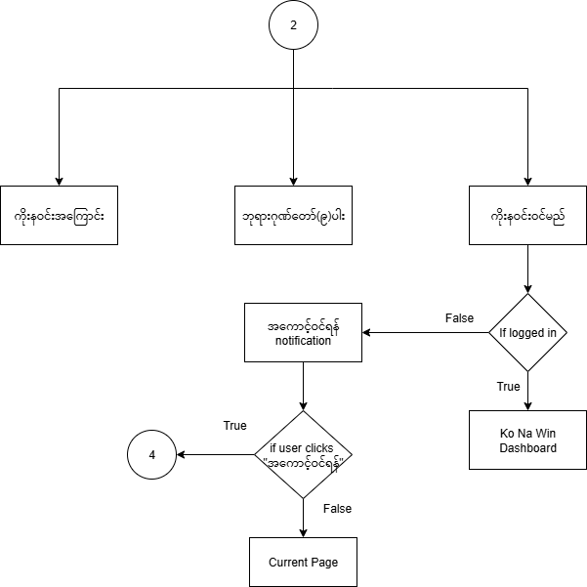This flowchart provides a detailed look into the user journey and functionalities within the "ကိုးနဝင်း" (Koe Na Win) dashboard.

Figure 4.3.3: Koe Na Win Dashboard Flowchart

**Description:** This diagram illustrates the flow for accessing the Koe Na Win dashboard. It includes a decision point for user login status, leading to either a login notification or direct access to the dashboard. It also outlines sub-paths for activities related to the Nine Attributes of the Buddha and additional Koe Na Win functionalities.

## 4.3.4 About Us Flowchart

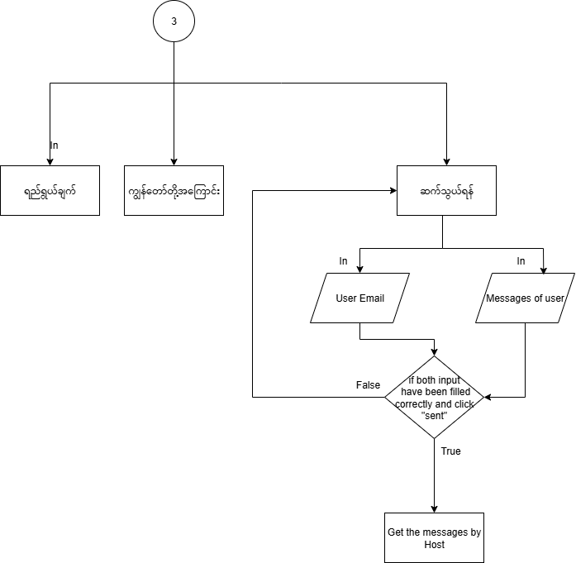This flowchart outlines the navigation and interactions within the "ကျွန်တော်တို့အကြောင်း" (About Us) section, including its sub-pages.

Figure 4.3.4: About Us Section Flowchart

**Description:** This diagram details the navigation within the About Us section, showing paths to the Mission (ရည်ရွယ်ချက်), About Us (ကျွန်တော်တို့အကြောင်း), and Contact Us (ဆက်သွယ်ရန်) pages. It also illustrates the process for submitting user inquiries via email through the Contact Us form, including input validation and message delivery.

## 4.3.5 Account Management Flowchart

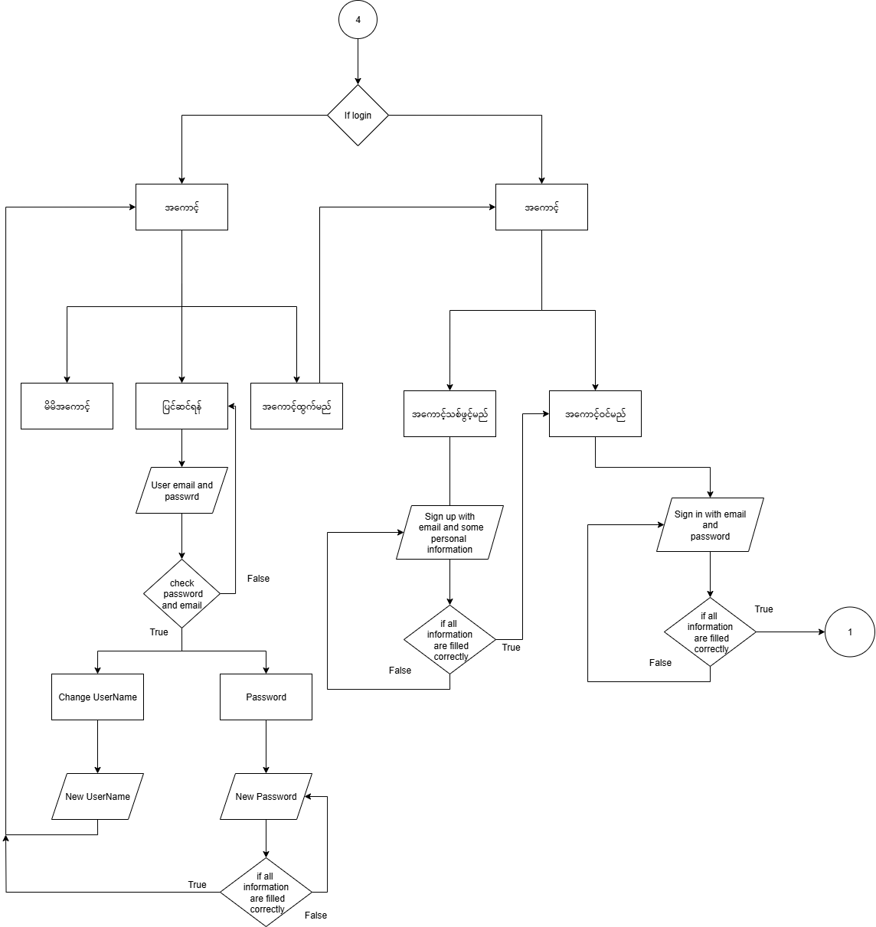This flowchart depicts the various processes involved in user account management, including login, registration, and password handling.

Figure 4.3.5: Account Management Flowchart

**Description:** This diagram illustrates the different account-related functionalities, including user login authentication, password management (change and reset), and profile updates. It shows decision points for login success/failure and correct information submission, guiding users through account-related actions.

## **4.4. Entity-Relationship (ER) Diagram**

This diagram visually represents the database structure, showing the entities (tables) within the Ko Na Win system and the relationships between them.

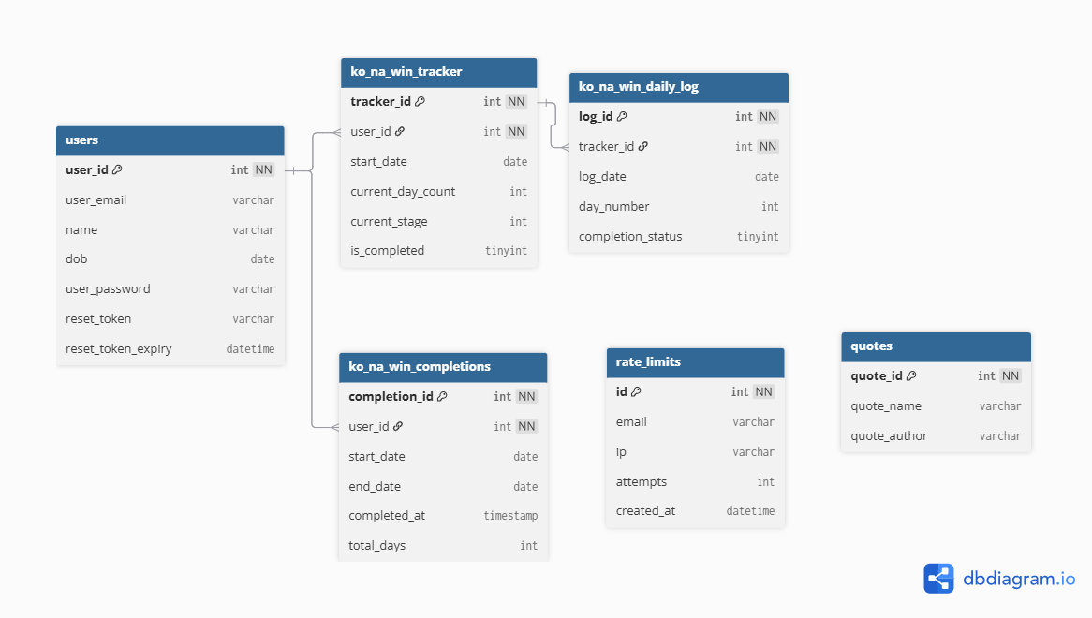

Figure 4.4Entity–Relationship Diagram for User, Rate Limit, Quote, and YouTube Video Table

# **Chapter - 5**

# **Implementation and Features**

# **5.1. Key Feature Implementation**

The core functionalities of the Lotus Shrine application are implemented as follows:

* **Virtual Buddha Pay Homage Room:** This central feature encompasses several integrated elements. Users can virtually visit pagodas, with the capability to view specific traditional "corners" of the pagoda (e.g., Monday corner) based on their birthday, enhancing a personalized spiritual connection. This visual experience is complemented by background offering audio that can be continuously played.
* **Buddha Teachings (Audio & Video):** The application integrates a dedicated section for accessing various Buddha Teachings.
  + **Dhamma Teachings (Audio):** Accessed by clicking on the "ဓမ္မတရားတော်များ" square on the services page.
  + **Buddha Teaching (Video):** Accessed by clicking on the "တရားတော်များ" square on the services page. These sections provide users with comprehensive resources for learning and spiritual growth.
* **Meditation Timer & Guided Sessions:** Users can engage in meditation with a customizable timer. This feature includes calming visuals and guided audio sessions. The integration of AI-powered posture detection using Google Teachable Machine provides real-time feedback during meditation, helping users maintain correct posture and reduce injury risk. This functionality is accessible by clicking the "တရားထိုင်ရန်" square on the services page.
* **Traditional Chants (Paritta Sutta Audio Player):** An in-app audio player allows users to listen to an organized playlist of Suttas. This player includes standard controls and optional subtitle display, enabling users to listen while browsing other sections of the app.
* **Daily Dhamma Quote:** A backend API is used to dynamically fetch and display a new Dhamma quote daily, which is stored in the MySQL database. This is prominently displayed on the homepage. *
* **Virtual Pagoda View:** Users can click on the "ဘုရားများ" square on the services page to access the virtual pagoda viewing feature. (This will be presented in a subsequent figure.)
* **Koe Na Win Dashboard:** A comprehensive spiritual practice management system accessible to logged-in users. Its features include:
  + **Vow Management:** Users can initiate a new 81-day vow or resume an existing one from their current day and stage.
  + **Daily Progress Tracking:** Users can mark a day as completed (once per day). The system features visual progress bars, percentage completion trackers, and automatically progresses users through the 9 stages.
  + **Mantra System:** Displays the specific mantra and required repetition count for the user's current day and stage, with full Unicode support for the Myanmar language.
  + **Meat-Free Day Alerts:** The system automatically highlights and notifies users of vegetarian days (every 5th day of a stage).
  + **Historical Records:** Users can view their past vow completions and achievements.
  + **Cultural Integration:** The dashboard integrates the Myanmar Buddhist calendar and uses culturally appropriate design elements.
* **Explanation of Nine Attributes of the Buddha:** Users can access an explanation of the Nine Attributes of the Buddha by clicking on the "ဂုဏ်တော်ကိုးပါး" square on the services page. (This will be presented in a subsequent figure.)
* **Contact Us:** The application includes a "ဆက်သွယ်ရန်" (Contact Us) webpage, which is a sub-page of the "ကျွန်တော်တို့အကြောင်း" (About Us) section. This "About Us" section further includes "ရည်ရွယ်ချက်" (Mission) and "ကျွန်တော်တို့အကြောင်း" (About Us) itself. This page allows users to send inquiries or feedback. *

### **5.2. Component Communication and State Management**

* **Global State:** A context manages the global music player state, ensuring a seamless audio experience across different pages. User authentication data is persisted using Local Storage.
* **Data Flow:** Components primarily communicate via props (parent to child data passing) and the React Context API for global state sharing (MusicPlayer, Authentication). React Router manages navigation and URL-based state changes.
* **Form Handling:** Forms throughout the application utilize React Hook Form for efficient state management and validation.
* **API Integration:** The frontend communicates with the PHP backend using the Fetch API, sending and receiving JSON data via RESTful principles. Backend endpoints handle specific requests like user authentication, registration, and contact form submissions.

### **5.3. Build and Deployment Considerations**

* **Development Environment:** Vite serves as the build tool and development server, facilitating rapid development and hot module reloading.
* **Build Process:** The build command compiles TypeScript, bundles React components, and optimizes assets (images, fonts, sounds, CSS) for production deployment.
* **Responsive Design:** Tailwind CSS's responsive classes and custom hooks are employed to ensure the application adapts seamlessly to various devices, including mobile.
* **Animations and User Experience:** The project utilizes **shadcn/ui** components, which are built with Tailwind CSS, to provide a consistent and accessible user interface. For rich and complex visual effects, **GSAP (GreenSock Animation Platform)** is employed for high-performance animations. Additionally, Framer Motion is used for smooth page transitions and micro-interactions. Error handling is implemented with try-catch blocks, and user feedback is provided via toast notifications and form validation.

This comprehensive approach ensures that Lotus Shrine is not only functional but also provides an engaging and meaningful spiritual experience.

# **Chapter – 6**

# **User Interface and Experience**

# **6.1 Overview**

# The User Interface (UI) and User Experience (UX) of the Lotus Shrine Project are designed to create a simple, spiritual, and immersive environment for users who wish to engage in virtual religious practices. The primary goal is to make the system intuitive, aesthetically pleasing, and accessible to all types of users, regardless of technical background.

# **6.2 Design Principles**

The UI/UX of the Lotus Shrine application is based on the following principles:

* **Consistency:** A uniform layout and navigation structure across all pages.
* **Simplicity:** Minimal distractions, focusing only on essential elements for spiritual interaction.
* **Accessibility:** Clear fonts, high-contrast visuals, and multilingual support (English and Burmese).
* **Immersion:** Use of soft Buddhist-inspired colors, lotus icons, and calming visuals.
* **Color Palette:** The Lotus Shrine uses a soft and spiritual color palette inspired by Buddhist aesthetics:



**Figure 6.1: Color Palette of Lotus Shrine**

# **6.3 User Interface Design**

# **6.3.1 Home Page**

# 

**Figure 6.2: Home Landing Page**

**6.3.2 Login Page**

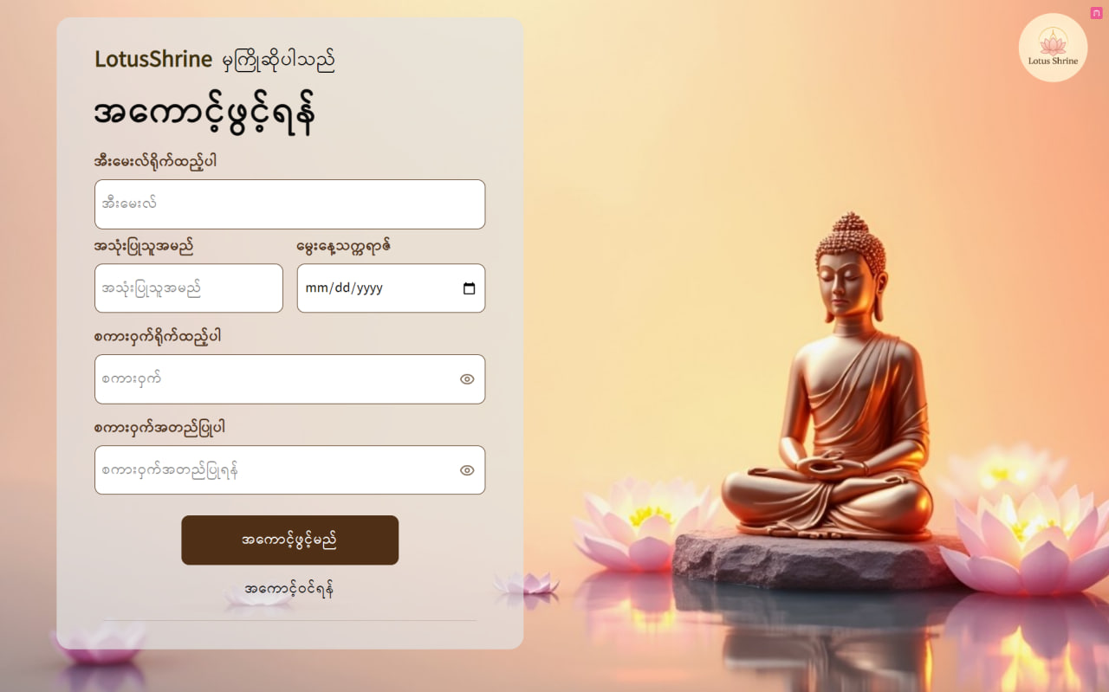

**Figure 6.3: Home Landing Page**

# **6.3.3 Sign-In Page**

# 

**Figure 6.4: Sign-xIn Page**

**6.3.4 Pagoda Page**

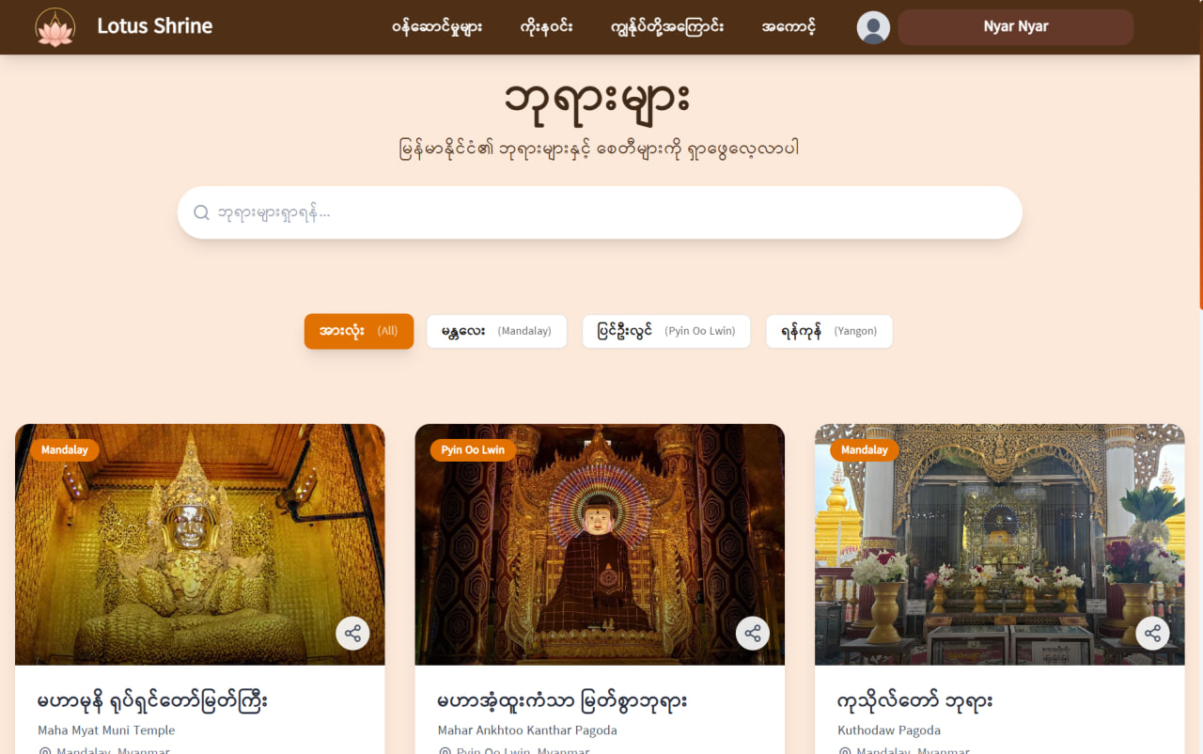

**Figure 6.5: Pagoda Page**

# **6.3.5 Pagoda Page (Pagoda History Function)**

# 

**Figure 6.6: Pagoda Page (Pagoda History Function)**

**6.3.6 Pagoda Page (Pagoda Pray Function)**

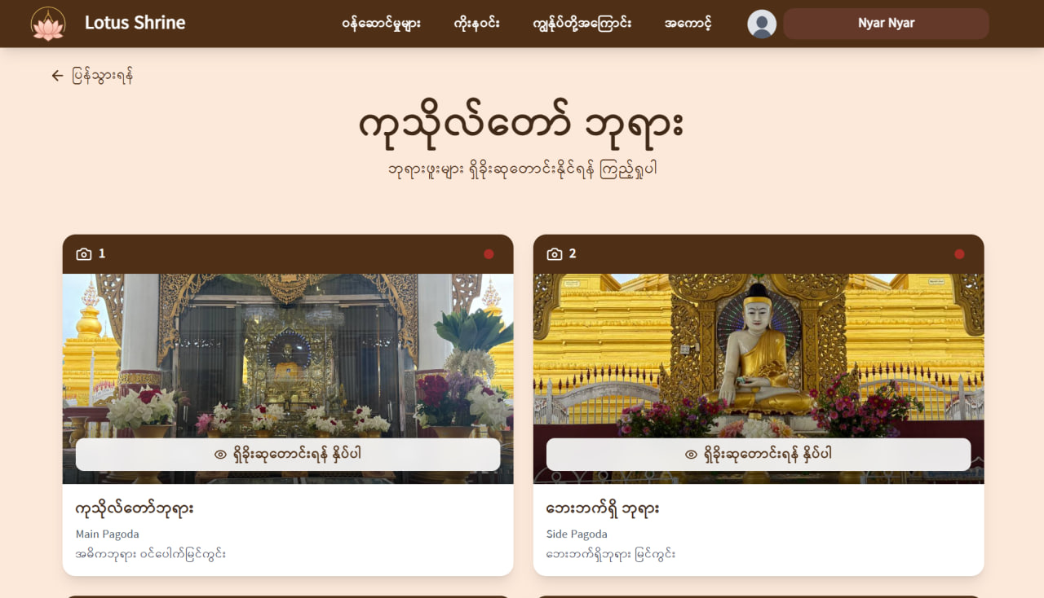

**Figure 6.7: Pagoda Page (Pagoda Pray Function)**

# **6.3.7 Pagoda Page (Pagoda Pray Function (Cont.))**

# 

**Figure 6.8: Pagoda Page (Pagoda Pray Function (Cont.))**

**6.3.8 Mantras Page**

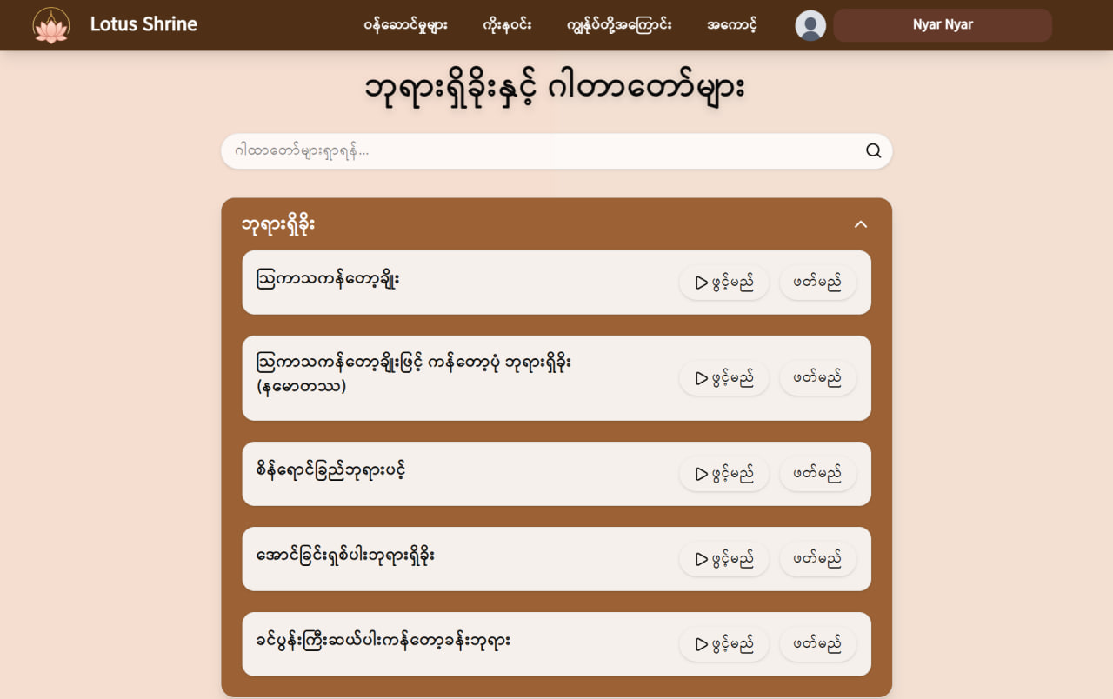

**Figure 6.9: Mantras Page**

# **6.3.9 Mantras Page (Cont.)**

# 

**Figure 6.10: Mantras Page (Cont.)**

**6.3.10 Sermon Page**

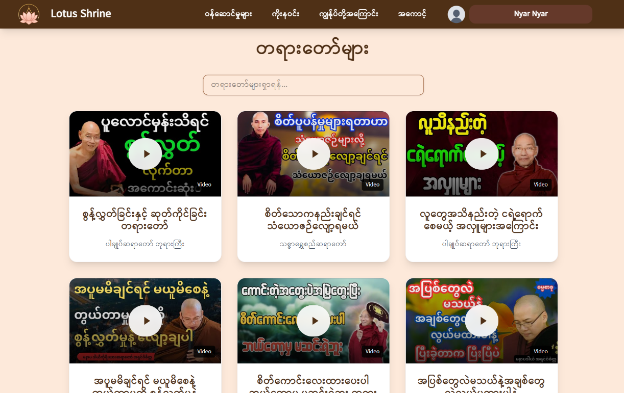

**Figure 6.11: Sermon Page**

# **6.3.11 Dhamma Books Page**

# 

**Figure 6.12: Dhamma Books Page**

**6.3.12 Meditation Page**

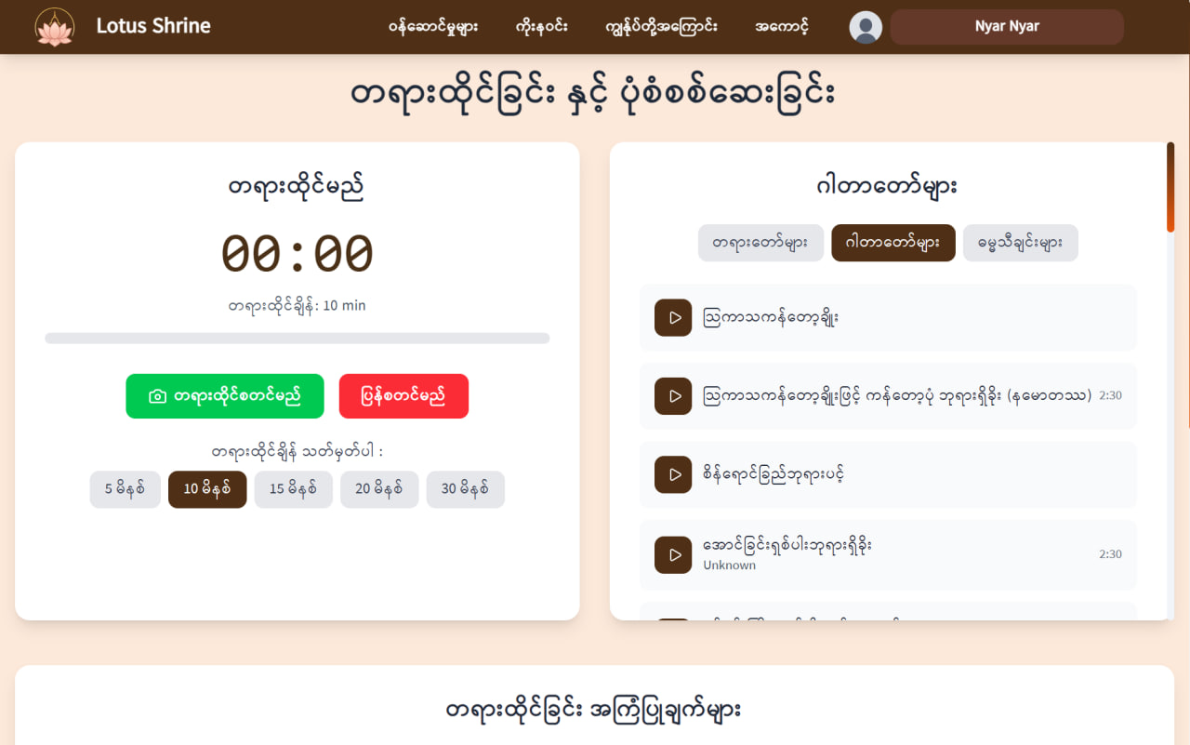

**Figure 6.13: Meditation Page**

# **6.3.13 Meditation Page (Cont.)**

# 

**Figure 6.14: Meditation Page (Cont.)**

**6.3.14 Meditation Page (Cont.)**



**Figure 6.15: Meditation Page (Cont.)**

# **6.3.15 Koe Na Win Page**

# 

**Figure 6.16: Koe Na Win Page**

**6.3.16 Koe Na Win Grades Page**

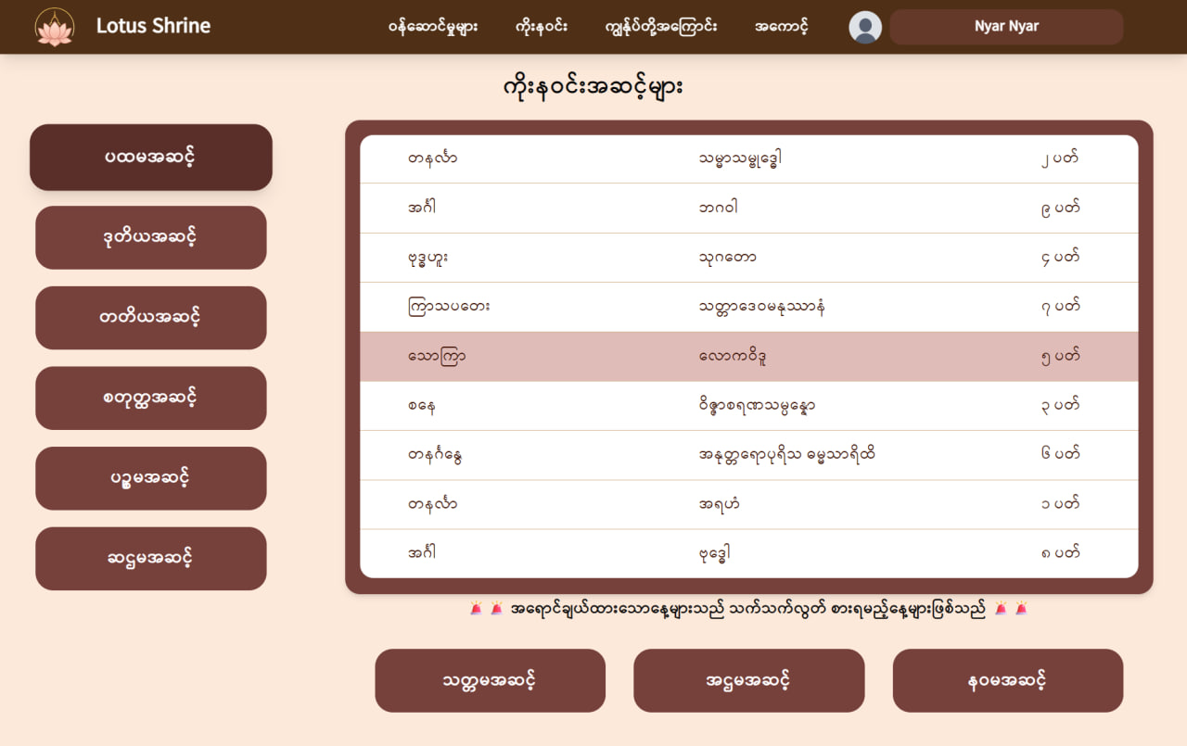

**Figure 6.17: Koe Na Win Grades Page**

# **6.3.17 Project Objectives Page**

# 

**Figure 6.18: Project Objectives Page**

**6.3.18 About Developers Page**

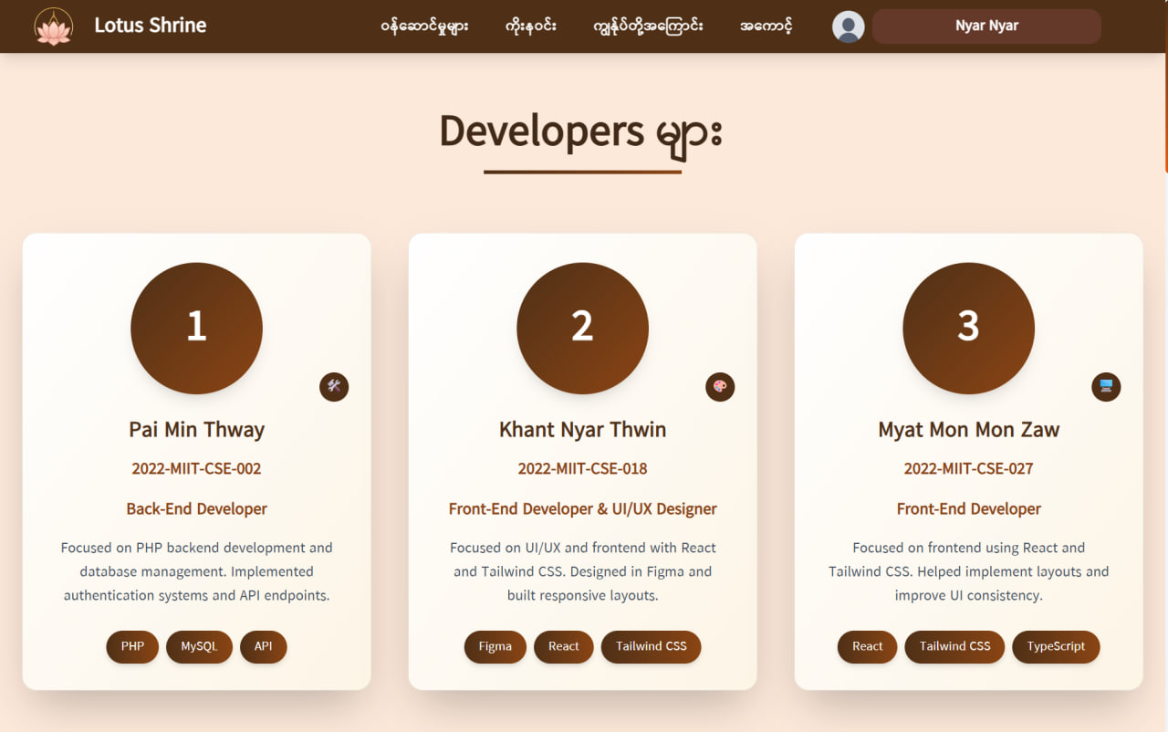

**Figure 6.19: About Developers Page**

# **6.3.19 My Account Page**

# 

**Figure 6.20: My Account Page**

**6.3.20 Edit Account Page**

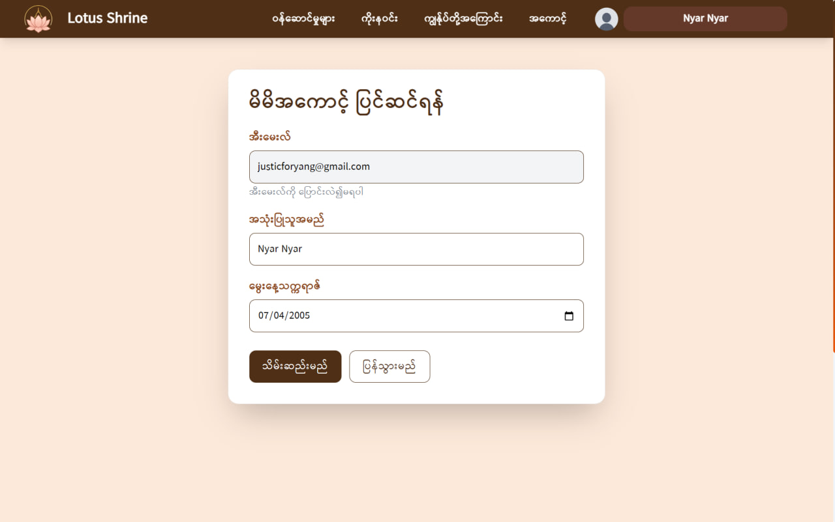

**Figure 6.21: Edit Account Page**

# **6.3.21 Koe Na Win Dashboard Main Page**

# 

**Figure 6.22: Koe Na Win Dashboard Main Page**

**6.3.22 Koe Na Win Dashboard Information Page**

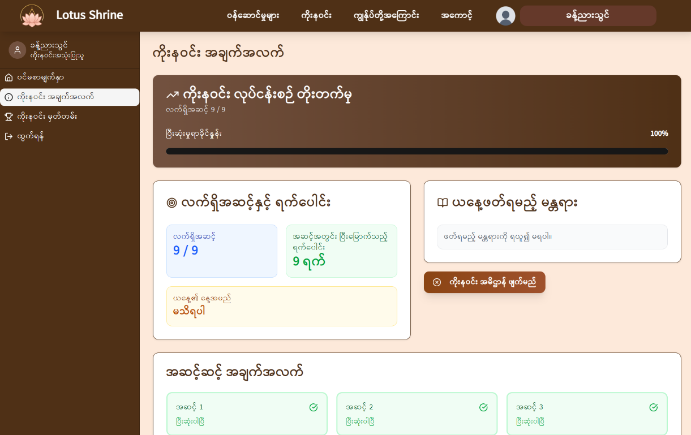

**Figure 6.23: Koe Na Win Dashboard Information Page**

# **6.3.23 Koe Na Win Dashboard Certificate Page**

# 

**Figure 6.24: Koe Na Win Dashboard Certificate Page**

## **Chapter – 7**

## **Future Enhancements and Considerations**

Beyond the current scope, we envision several potential enhancements that could further enrich the Lotus Shrine experience:

* **Donation System:** Considering the implementation of a secure donation system for monasteries or related causes, if aligned with project goals.
* **Augmented Reality (AR) Mode:** Investigating an AR mode for an even more immersive pagoda experience, allowing users to superimpose virtual pagodas into their real-world environment.
* **Expanded Content:** Continuously adding more Buddha Teachings (audio/video), Paritta Suttas, and Dhamma quotes.
* **Enhanced AI Meditation Posture Recognition:** Expanding the AI's capabilities to recognize and provide feedback on a wider array of specific meditation postures. This enhancement would include:
* **Posture Selection:** Giving users the option to specify their desired meditation posture, such as:
* Full Lotus (Padmasana)
* Half Lotus
* Burmese Position
* Easy Pose (Sukhasana)
* Seiza (kneeling)
* Chair Sitting
* Corpse Pose (Savasana, lying flat)
* Reclined Supported Pose (lying with bolster support).

## **Chapter – 8**

## **Conclusion**

The Lotus Shrine web application project has been successfully brought to completion, fully realizing its goal of harmonizing ancient Buddhist practices with modern web technology to create a peaceful, accessible, and spiritually enriching digital space. Our dedicated team has implemented all core features to a high standard, including the immersive virtual pagoda, guided meditation with AI-powered posture detection, comprehensive Buddha Teachings library, and—significantly—the fully integrated and personalized "Koe Na Win Dashboard." This dashboard stands as a sophisticated tool that empowers users to faithfully maintain their 81-day vow with automated guidance, detailed progress tracking, and culturally authentic reminders.

The application is now a fully functional, polished, and impactful spiritual platform. It effectively bridges geographical limitations, providing a unique and meaningful way for individuals to cultivate mindfulness, devotion, and a deeper connection to their faith in the digital age. Lotus Shrine is ready to serve its purpose as a valuable companion on the user's spiritual journey.